A CLAS Information Technology Group document
Mac OS X Network Printing
Connecting to the IOWA domain print queues.

Macintosh OS X

The following steps enable a workstation to utilize the centrally managed print queues overseen by ITS, which makes it easy to enable additional features and to control troublesome printing problems. These directions are for Macintosh OS X 10.5 and 10.6 (and 10.7 macs on the Iowa domain). Access to these print queues is granted via HawkID accounts, so if a HawkID password is changed, the printer connection must be deleted and reconnected. Also note that these printers will stay on the machine, and allow other users to utilize them with the credentials of the user account that originally connected to the printer (these instructions should not be used on multi-user computers).
Please note that this document may only be a general guide due to the different printer manufacturers available and the various options that may be installed on each printing device.

Macintosh OS X 10.5 - 10.7 ---> Printing from an AD bound Macintosh

Preferred Method for Macs imaged with Casper and bound to Active Directory
Using System Preferences / Print & Fax Panel - Using KSMB Printing

1. Select the Print & Fax panel in the Systems Preferences selection under the Apple Menu in the finder

2. Add the “Advanced” tab to your Add Print tool bar, if it is not listed. Hold down the Control Key, Click on the “Default” icon in the toolbar, and select “Customize Toolbar”. After the selection window appears, drag the “Advanced” icon to you Add Printer Toolbar.
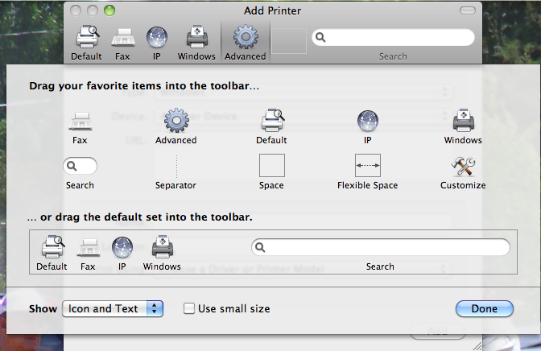

3. After you have the Advanced selection tab installed, select it. Choose “Windows Printer via SAMBA with Kerberos support 1.0” from the pop-up menu.
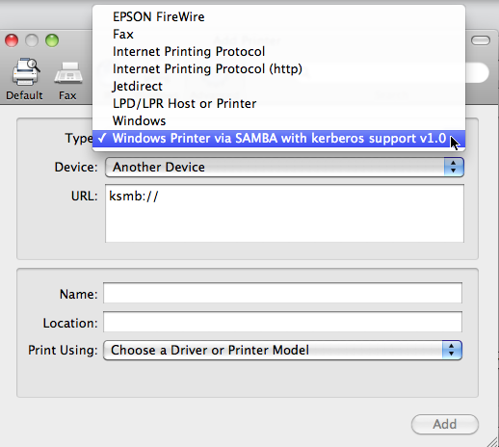

- After choosing the Windows choice, you will now have a “ksmb://” url to complete. Complete the print queue address with the server address followed by the print queue. An example is: ksmb://iowaprint05.iowa.uiowa.edu/MH-38-C.
  - The Name of the queue will be the same as the print queue. In the example, we would use MH-38-C.
  - Location is the psychical location of the printer; example MH-38.
  - Choose Drive of Printer Model. From the pop-up menu, “Select driver to use”. In our example, we searched for 4250 by typing in 4250, and found a matching HP Laserjet 4250 printer driver. If a driver is not available, and the computer does not find one during it’s search, you will need to download the driver from the printer manufacturer’s website.

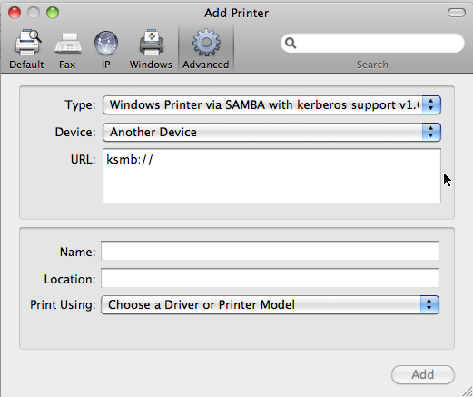
5. Once your printer is installed, try printing your document to the new print queue. In OSX, your hawk id and password are now automatically passed along with the print job to the AD print queue, and your job should print.

Macintosh OS X 10.5 /10.6 ---> Printing from a NON AD bound Macintosh

Using System Preferences / Print & Fax Panel

1. Select the Print & Fax panel in the Systems Preferences selection under the Apple Menu in the finder

2. Add the “Advanced” tab to your Add Print tool bar, if it is not listed. Hold down the Control Key, Click on the “Default” icon in the toolbar, and select “Customize Toolbar”. After the selection window appears, drag the “Advanced” icon to you Add Printer Toolbar.

3. After you have the Advanced selection tab installed, select it. Choose Windows from the pop-up menu.

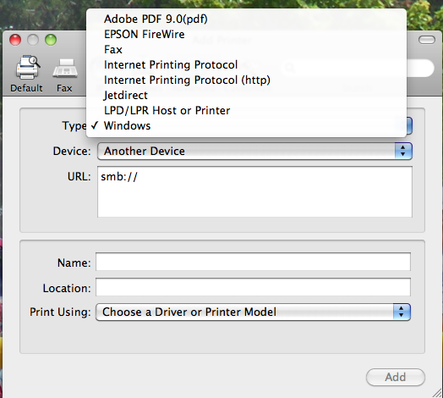

- After choosing the Windows choice, you will now have a “smb://” url to complete. Complete the print queue address with the server address followed by the print queue. An example is: smb://iowaprint05.iowa.uiowa.edu/MH-38-C.

- After choosing the Windows choice, you will now have a “smb://” url to complete. Complete the print queue address with the server address followed by the print queue. An example is: smb://iowaprint05.iowa.uiowa.edu/MH-38-C.
  - The Name of the queue will be the same as the print queue. In the example, we would use MH-38-C.
  - Location is the physical location of the printer; example MH-38.
  - Print Using - From the menu, choose “Select driver to use”. In our example, we searched for 4250 by typing in 4250, and found a matching HP Laserjet 4250 printer driver. If a driver is unavailable, download the driver from the printer manufacturer’s website.

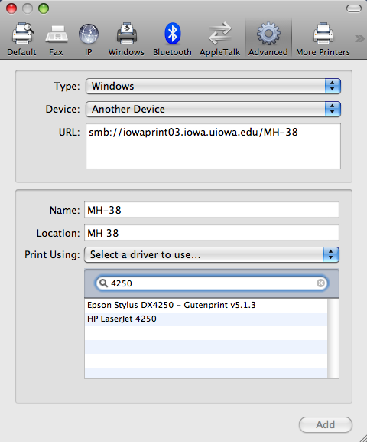

- Once your printer is installed, try printing your document to the new print queue. In OSX.5, you will need to authenticate to print queue with your HawkID & password, in order for the job to print.

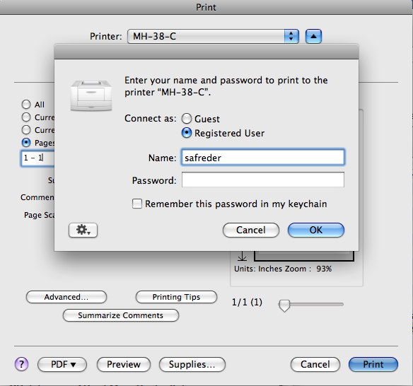

Ver 10.12.14

