Syllabi Repository Project
With thanks to Bill Evanson and Derek Henscheid for their work on this project
Purpose
Encourage students to
- create balanced schedules
- register for courses that meet the student’s academic readiness
- find tutoring or services earlier
- arrange schedules to accommodate course workload
- be more willing to try course in unfamiliar subjects
- Eliminate some course drops
Give advisors more information to help students
- explore new areas and interests
- enroll in the level of appropriate course (as in math or computer science)
Encourage faculty and staff to share syllabi in order to
- create course consistency when needed
- give examples of departmental and CLAS policy
- share best practices
- help mentor new faculty
- more efficiently share information about course equivalencies and alignment
- facilitate interdisciplinary and cross-listing
When
In CLAS, syllabi can be attached for viewing on ISIS (after logging in) for Spring 2015, the pilot period for this project. The tool will be operational in early October for the spring semester.
How to attach a syllabus
Departmental administers collect syllabi and approve them for compliance with CLAS and UI policies. Syllabi must be saved as pdf files with the following title format: Subject Acronym; Course and Section Number [section only if syllabi is unique by section]; Instructor (primary or supervisor) Name and key words in title:
CLAS_3000_001_World_Design_Susan_Smith
After syllabi are approved, the syllabi can be added to ISIS using ICON by the instructor, with the upload to ICON and ISIS happening simultaneously. Departmental administrators can also choose to post the syllabi through the offerings planner, once the course is opened in view mode, as below:

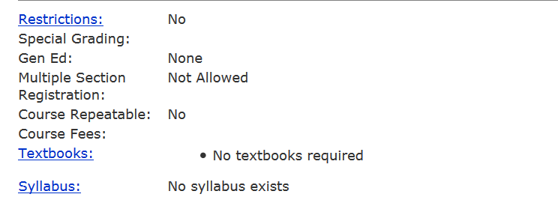
Who will see the syllabus?
The syllabus may only be accessed once a person is logged on to ISIS with the HawkID and password.
What will a viewer see on ISIS if there is no syllabus added?
The field “Syllabus” will not be visible to the viewer; nothing will appear.
What if the course does not require a syllabus?
The option of “Syllabus not required” may be chosen by the departmental administrator through the offerings planner (open view and go to Syllabus), as it is with textbooks. Choosing this option is recommended if no syllabus is available so students will not ask to see one.
How long will syllabi be left on ISIS?
Syllabi will remain on ISIS indefinitely, helping to build a record of syllabi. Currently posted syllabi will not be carried over to the next session since courses and their content frequently change, but students will be able to look at syllabi for any past session.
Must every CLAS instructor post a syllabi on ISIS?
Instructors are not required to post a syllabus on ISIS during the pilot as the College evaluates the project. However, the College strongly encourages instructors offering GE courses and other lower-level elective courses to have syllabi posted. We hope departments discuss this issue and discuss recommendations with the College on this matter.
Is there a deadline for posting syllabi?
Please make sure syllabi are added as soon as they are ready for students. Earlier is better since it can help students to make wise enrollment choices. However, with ER earlier this year and in future years, this will be hard for faculty to do. Even if the syllabi are posted after the semester begins, they can be useful for students, advisors, and instructors planning future enrollments and classes or for staff answering questions. When syllabi are ready, they should be added.
Will syllabi be also in a second, more stable repository, which can then be searched and will contain a longer history than ISIS?
This is phase two of the project and is the reason that files must be given consistent titles. Please send us your suggestions for how this repository might or should function.
Can instructors post their own syllabi?
Course syllabi may be posted using the MAUI offerings planner or may be added via ICON. Instructors are familiar with ICON and adding syllabi that way makes sense. Departments must still check syllabi for adherence to UI and CLAS policies and procedures. The files must be saved as pdf files with the title giving in this format: CLAS_3000_001_World_Design_Susan_Smith
If new syllabi are not ready, can we post old ones?
Syllabi often change, particularly the editions of textbooks. Posted syllabi must be current so students are not confused and buy the wrong books.

