How To: Electronically Sign your APR
- Log into APR
- Once you are comfortable with your data for the annual review for this year click “CLAS Annual Review”
- Click “Add New Item”
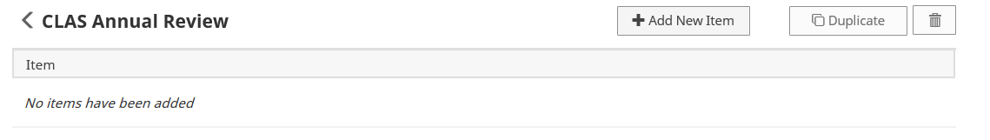
- Select “2016” in the drop down titled Calendar Year, click the checkbox “I hereby affirm my APR data is up to date.” Then, enter the current date.
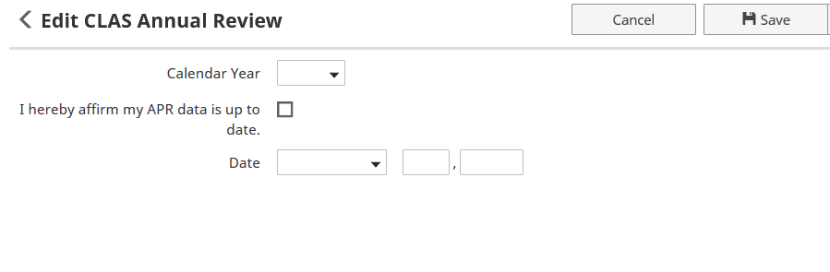
- Click “Save”

