Simpler Recording Process
from Jennifer Stone via Michael Espey, an Instructional Technology Consultant with Office of Teaching, Learning & Technology

I also wanted to make a note about a new option (enabled on Tuesday of this week) called Panopto Capture that can be used to record quickly and without installing anything on your computer. It is an entirely browser based recorder that is perfect for this sort of setup.

To use this, they would follow the below steps:
- Click on UICapture in the navigation bar.
- Open the correct folder for this assignment. (Discussions Board: Upload Videos)
- Open the Create drop-down at the top.
- Select Panopto Capture from the list.
- Select the Audio/Video sources you would like to use in your capture. You can also adjust quality settings from under the gear icon in the lower right.
- Click the red record button at the bottom to begin recording.
- Wait for the recording to show the Upload Complete status before closing the window.
- Follow the Choose track on this guide to embed your recording in ICON. (https://teach.uiowa.edu/UICapture/guides/student/ICON-Assignment)

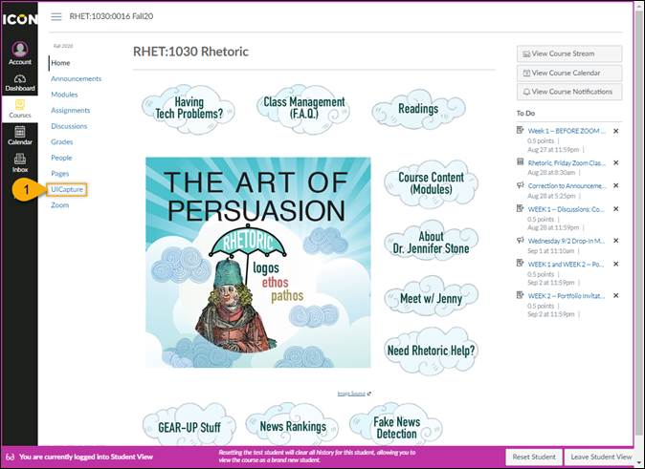
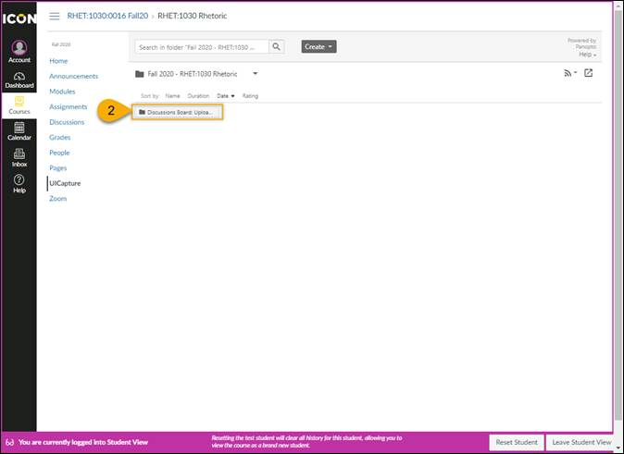
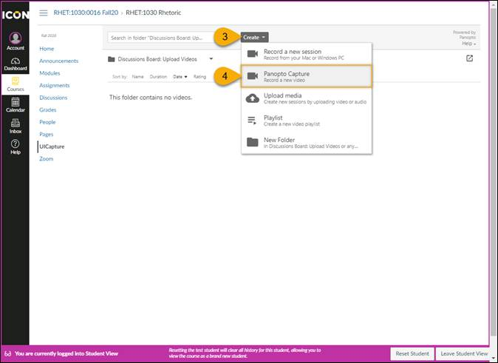
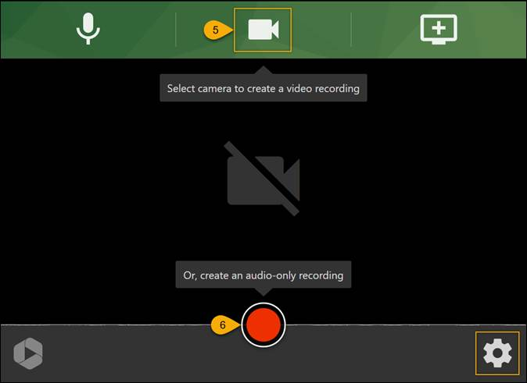
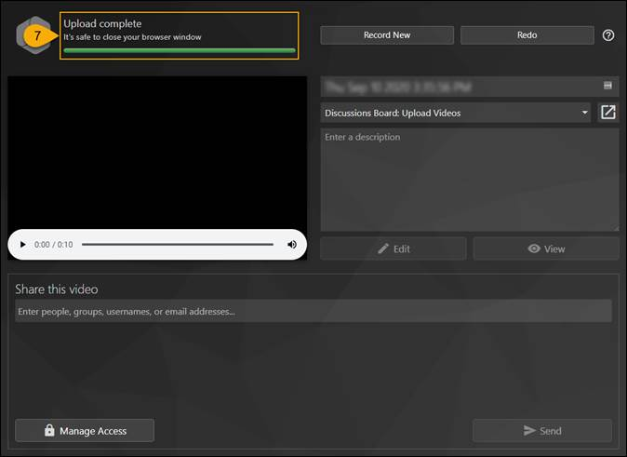

This utility works well from within Chrome, Edge, and FireFox on both macOS and Windows right now. The support for iOS and Andoid devices is coming

