A CLAS Technology Services document

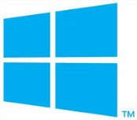 Using Remote Desktop and Mapping Network Drives from Off-Campus
Windows 7

This document explains how to use Remote Desktop and map network drives using either a university-managed or personally-owned Windows 7 computer while off-campus. Remote Desktop allows you to remotely login to your university computer and utilize resources (software and network drives) as if you are actually sitting at that computer.
Mapping a network drive to your computer allows you to access the files stored within those drives. Please work with your IT Support Consultant to determine which option is best for you.

Register Computer With PowerUP!

Registering your computer with this tool allows you to remotely turn on your computer so you are able to access it using Remote Desktop Connection.

NOTE: This is not necessary if you only wish to map network drives. Please skip to the next section titled “Install & Configure Cisco VPN Client”.

- While signed in to the university computer you will be using Remote Desktop Connection to access, go to the ITS DIY Tools site, click the Login button and log in using your HawkID and password.

- Select the Tools tab on the top ribbon and click the gold PowerUp! header.

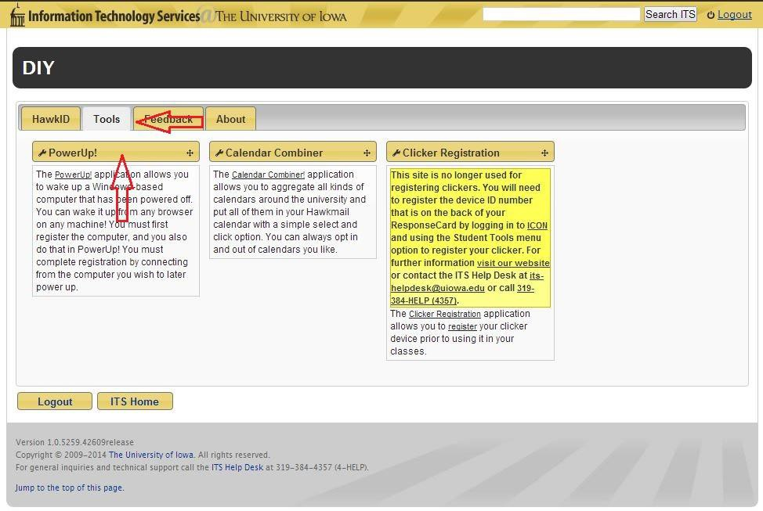

- A list of all your computers currently registered with PowerUp! will appear. If your current computer is not in the list, select Add current computer.

NOTE: If your current computer is already listed, you can use the alarm clock icon to the left of the computer name to remotely turn on this computer in the future. Skip to step 6 in this section.

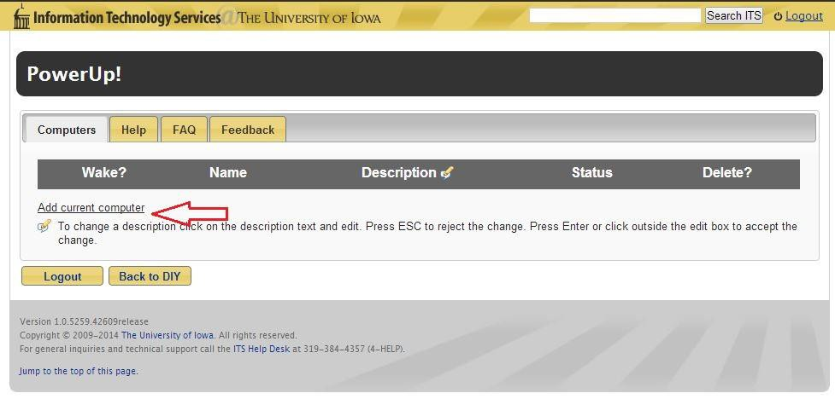

- The System Information window will appear.
  - Description: Enter a description for the computer you are registering.
  - Full Computer Name: enter the computer name followed by “.iowa.uiowa.edu” without quotations. Click on the blue question mark icon for help finding your full computer name.
  - Physical Address: Enter the physical address of your computer. Click the blue question mark icon for directions on finding this information.
  - Click the Register button to continue.

NOTE: Please contact your IT Support Consultant if you need help filling out any of these fields.

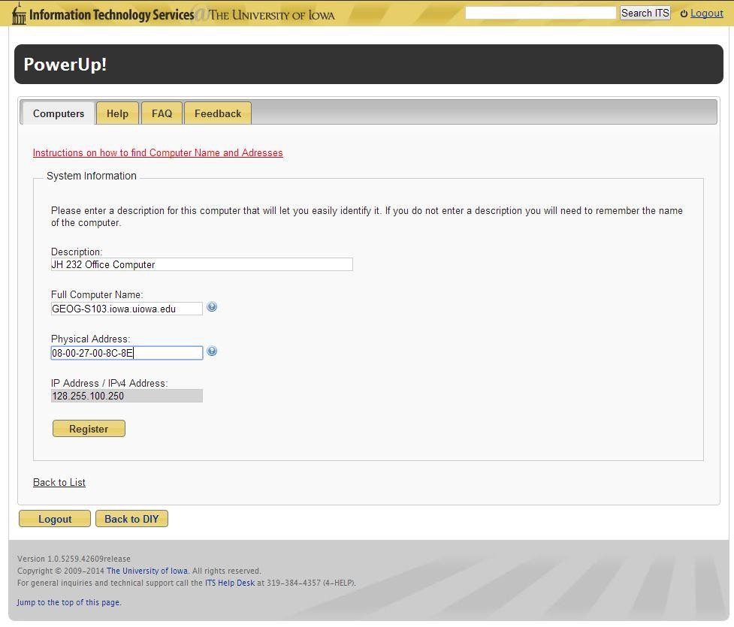

- You will be returned to the main PowerUp! window and your current computer will now be displayed in the list of registered computers.

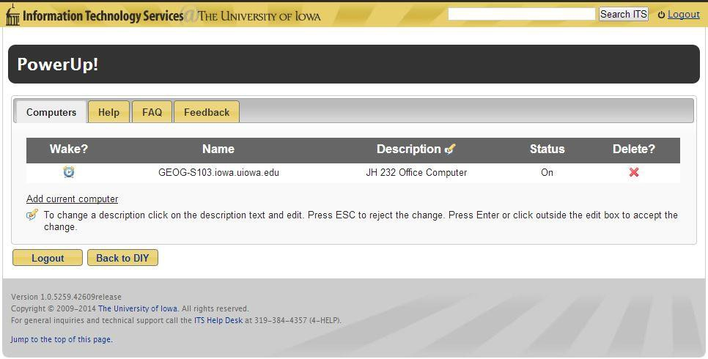

- To remotely turn on your computer in the future, repeat steps 1 and 2. Once you reach the main PowerUp! window, the current status of your computer is displayed. If it is listed as Off, click the alarm clock icon to the left of the computer name to turn it on.

- You will be taken to the status window where you can check on the status of your computer to see if it is fully powered on yet by clicking Check Status.

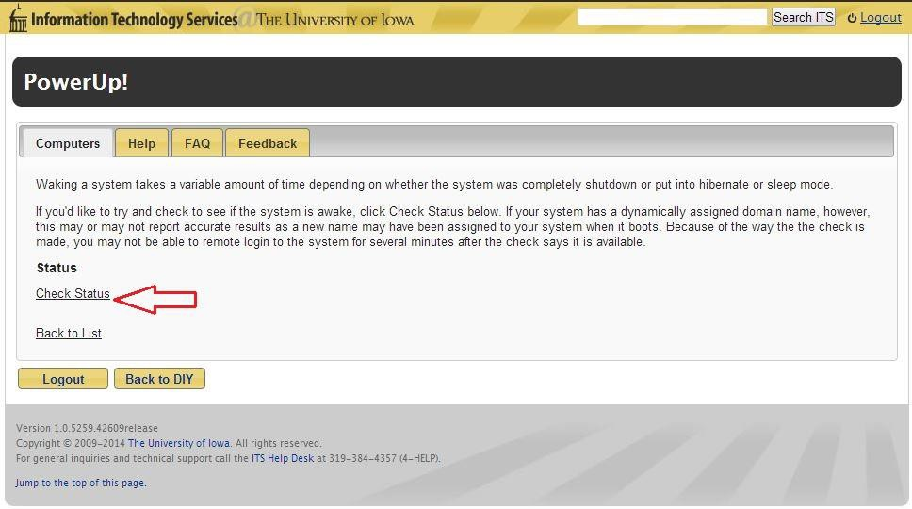

Install & Configure Cisco VPN Client

In order to access university resources from off-campus you must have the VPN client installed and be connected to the Iowa domain. If you are using a university-managed computer, the Cisco VPN Client should already be installed for you (skip to step 3 below). If you are using a personally-owned computer please follow the steps below to download, install and configure the Cisco VPN Client.

- Visit the ITS Software Download site and sign in using your HawkID and password. You may need to specify the Iowa domain by typing iowa\ before your HawkID.

- Click on the Cisco AnyConnect VPN Client link and select AnyConnect for Windows to begin downloading the installer. Save the installer to a location on your computer. Double click the file to begin the installation. Accepting all defaults, follow the instructions on the screen until the installation has completed.

- Go to the start menu, select All Programs, Cisco folder, Cisco AnyConnect Secure Mobility Client folder and select Cisco AnyConnect Secure Mobility Client.

- In the window that appears, enter vpn.uiowa.edu and click Connect.

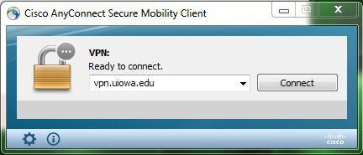

- Leave the Group dropdown set to Default. Enter your HawkID and password in the prompt that appears (do not enter iowa\) and hit OK. You should now be connected to the Iowa domain.

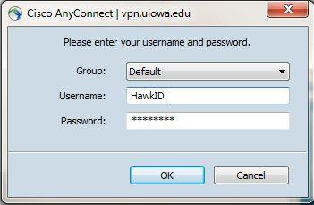

Option 1: Remote Desktop

Work with your IT Support Consultant to ensure you are authorized to remotely access your university computer. The Cisco AnyConnect Secure Mobility Client must be running to use Remote Desktop Connection.

- To use Remote Desktop to connect to your office computer, go to the start menu, select All Programs, Accessories, Remote Desktop Connection.

- In the Remote Desktop Connection window, enter your computer name followed by .iowa.uiowa.edu.

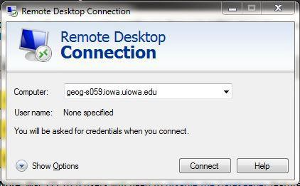

- Upon clicking Connect, you will be prompted to enter your HawkID and password. Make sure to enter iowa\ before your HawkID. A window will appear referencing a security certificate. Select Yes to continue. You should now be logged into the computer you specified.

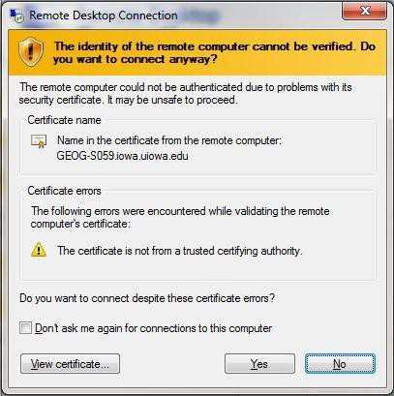

- If you receive the following window after hitting Connect, it is likely that your university computer is not powered on. Please refer to the first section in this document on using the PowerUp! tool to remotely turn on your computer.

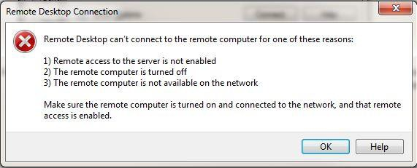

Option 2: Map Network Drives

Work with your IT Support Consultant to ensure you have the necessary addresses to your network drives. The Cisco AnyConnect Secure Mobility Client must be running to map a network drive.

You will need to repeat these steps after logging out and back into your computer. The Cisco VPN Client also times out after a certain period of inactivity. You will need to reestablish that connection to access any network drives that have been mapped.

- To map Network Drives, go to the start menu and open My Computer. Select Map network drive at the top.

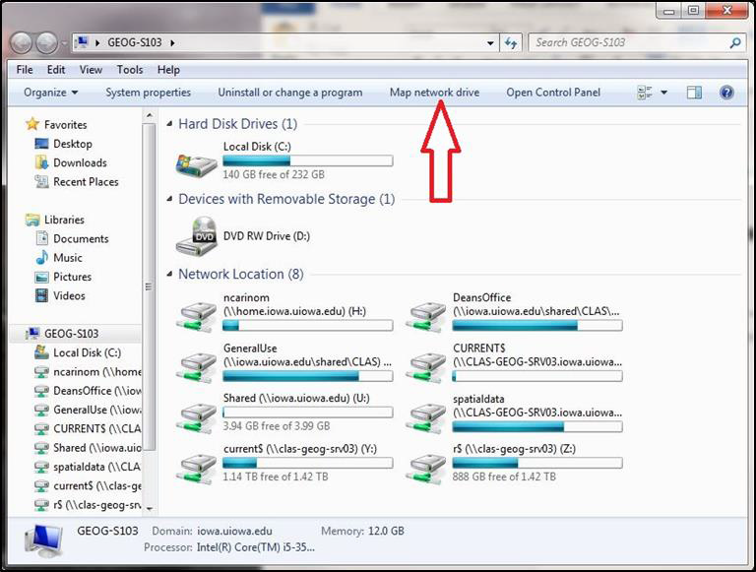

- The Map Network Drive window will appear.
  - Drive: From the dropdown menu select an unused letter, preferable something towards the end of the alphabet.
  - Folder: enter the desired address to the shared drive that you wish to connect to.
  - Check the box next to Connect using different credentials.
  - Select Finish and enter iowa\HawkID and your password when prompted.

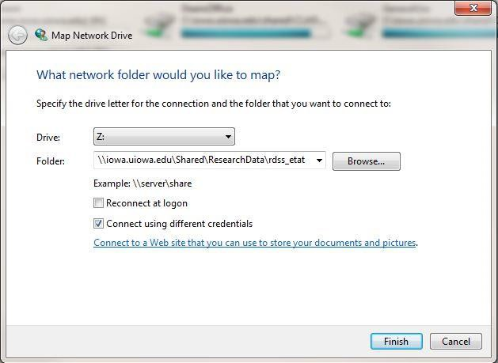

- A new window will appear showing the contents of the drive you just mapped. You can access this drive again by going to My Computer.

Notable Network Drive Paths:

H: Drive (Home): \\home.iowa.uiowa.edu\HawkID

L: Drive (Departmental): \\iowa.uiowa.edu\Shared\CLAS\Departmental\DepartmentName

N: Drive (General Use): \\iowa.uiowa.edu\Shared\CLAS\GeneralUse\DepartmentName

RDSS Drive (Research Data): \\iowa.uiowa.edu\Shared\ResearchData\rdss_HawkID

