Folder Permission Configuration Guide

Folder Permissions
This support section contains information on how to adjust the default security permissions on a folder. This information is geared specifically for the “Departmental” (L:\ drive) network space and Windows 7. If you have questions concerning the directions below please contact your departmental Information Technology Support Staff member.
By default, all the files and folders within a department’s shared L:\ drive folder have been set so that everyone that is officially affiliated with the department based on Human Resource has full control of the subfolders. This may include faculty, staff, emeritus, and possibly grad students on payroll. Additionally, the UI-DepartmentNameGoesHere includes the group OUA-CLAS-DepartmentNameGoesHere. This group contains the CLAS-IT Group members that support your department.
Important Notes
- The following group should ALWAYS have Full Control in order for things to function correctly: "UI-DepartmentNameGoesHere". These permissions will flow down from upper level folders and should not have to be added, unless you have changed the default security on a subfolder or file.
- Security permissions flow down from upper level folders, so set the needed permissions as far up as possible in order to save time and duplication of effort. This means that SubfolderB automatically gets the same settings as FolderA if it resides within FolderA.
- Deny permissions supersede Allow permissions, so try not to use the Deny settings (just leave the Apply setting blank instead of using Deny).
Enabling the Security Tab (if you do not already see it)
- Open Windows Explorer, and then select the Tools | Folder Options menu item.
- Click the View tab on the window that appears.
- Uncheck the box labeled "Use Simple File Sharing."
- Click the OK button to accept the changes and close the Folder Options window.
Creating a new folder on the departmental drive and setting permissions:
1. Right-click a blank area in the general use folder window, point to New, and then click Folder.
2. Next right click on the newly created folder and click properties, then the Security tab.
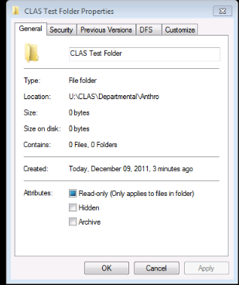

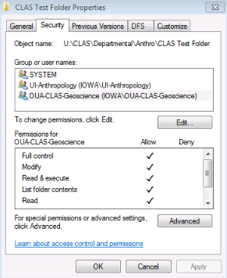
3. Click Edit to Add or Delete Groups or users permissions.

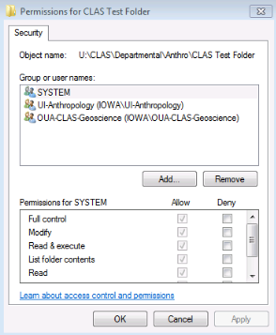
4. If you wish to delete permissions for a specific user or group, highlight the group or username and click Remove to delete. (Refer to Step 8)
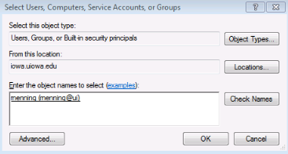
6. Enter the user’s HawkID and click Check Names to verify. Click OK.
5. If you wish to add permissions for a specific user or group, click Add to search for desired user or group.
7. Modify the user’s rights on the folder by checking the boxes in the permissions area for that user. At this point, you may allow full control of a folder for the user or allow read only access to the folder and contents.
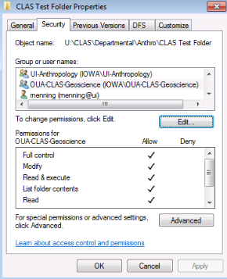
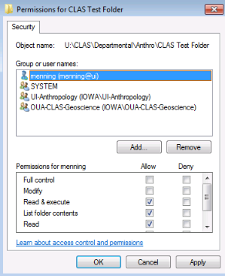
8. By default, a new folder in the departmental drive “inherits” the group UI- DepartmentNameGoesHere (HR auto-mated process). If you want to limit access, you can remove the UI- DepartmentNameGoesHere group and “lock” the folder down, but make sure you have given your HawkId full control before moving forward. To do so, the inheritance needs to be disabled. Click the Advanced button. Important: If you remove UI- DepartmentNameGoesHere, you are also removing the CLAS-OUA- DepartmentNameGoesHere (CLAS-IT Group’s management group). It is recommended you re-add this group so your IT support can help you in an emergency.
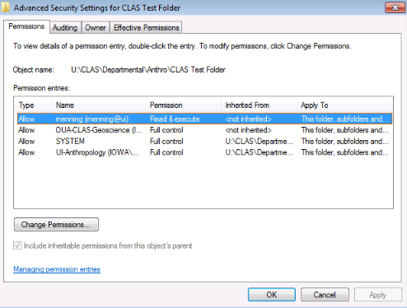
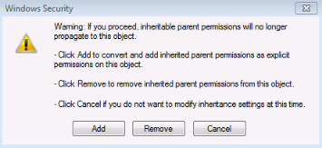
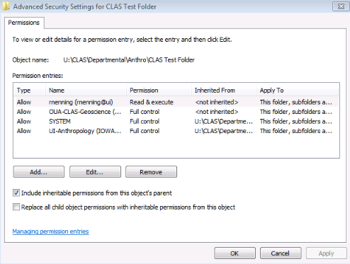
10. Click the Remove button.
10. Uncheck the box “Include inheritable permissions for the object’s parent.”
9. Click on the Change Permissions button.
10. Click Apply, then OK.
11. Modify the user’s rights (Refer to Step 7) and Click Apply, then OK.

